GOLF FORE RECOVERY OUTING
BENEFIT FOR:
OUR PRIMARY PURPOSE, INC.
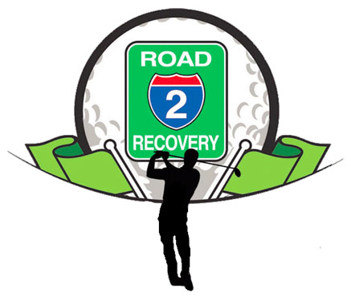
DATE: SATURDAY, AUGUST 19TH, 2017 1:00 P.M. SHOTGUN START
WHERE: GILBERTSVILLE GOLF CLUB
2944 Lutheran Rd.,
Gilbertsville, PA 19525
MISSION: Offering a laid-back fun competitive day of golf for all ages celebrating recovery from addiction. All proceeds from this dry golf event will go toward a local charity, OUR PRIMARY PURPOSE, INC. Whose primary focus is help raise awareness, support and educate about the addictions crisis and those who are directly affected. Additional donations can be made as well in sponsorships. THANK YOU!

FORMAT: 4 PERSON SCRAMBLE
INCLUDES: GREEN FEE, CART FEE, LUNCH, STEAK DINNER, CONTESTS, PRIZES AND DRINKS
SCHEDULE: 11:30- REGISTRATION, LUNCH & CAR WASH
1:00- SHOTGUN START
5:30- STEAK DINNER & PRIZES
7:30- END OF DAYS EVENTS
COST: $100 PER PLAYER (CAR WASH $10)
SIGN UP: CALL OR STOP IN PRO SHOP 610.323.3222
EMAIL KYLE G. RUANE- kruane@golfgilbertsvillegc.com
DEADLINE: AUGUST 12TH, 2017
PAYABLE TO: GILBERTSVILLE GOLF CLUB (CASH OR CHECK ONLY)

NAME PHONE EMAIL
1.

2.

3.

4.

DINNER ONLY $35 # OF GUESTS__________________

