GOLF FORE RECOVERY OUTING SPONSORSHIP FORM
BENEFIT FOR:
OUR PRIMARY PURPOSE, INC.
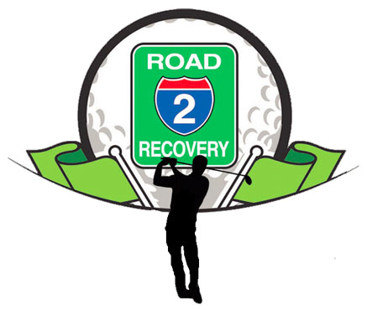
HOLE SPONSORSHIP- $50
NAME/BUSINESS: __________________________________________________
ADDRESS/ MESSAGE: _______________________________________________
____________________________________________________
PHONE #: ___________ WEBSITE: ______________________________

CORPORATE SPONSORSHIP
NAME/BUSINESS: __________________________________________________
ADDRESS: ____________________________________________________
____________________________________________________
PHONE #: ___________ WEBSITE: ______________________________
MONETARY DONATION: _________________________
GIFT DONATION: ______________________________
*CALL OR EMAIL KYLE G. RUANE W/ QUESTION 610.323.3222 OR KRUANE@GOLFGILBERTSVILEGC.COM*
***PLEASE MAKE ALL CHECKS PAYABLE TO GILBERTSVILLE GOLF CLUB***

